***UPHC PORTERLANE PHOTOS OF ROOMS OF HEALTH UNIT***

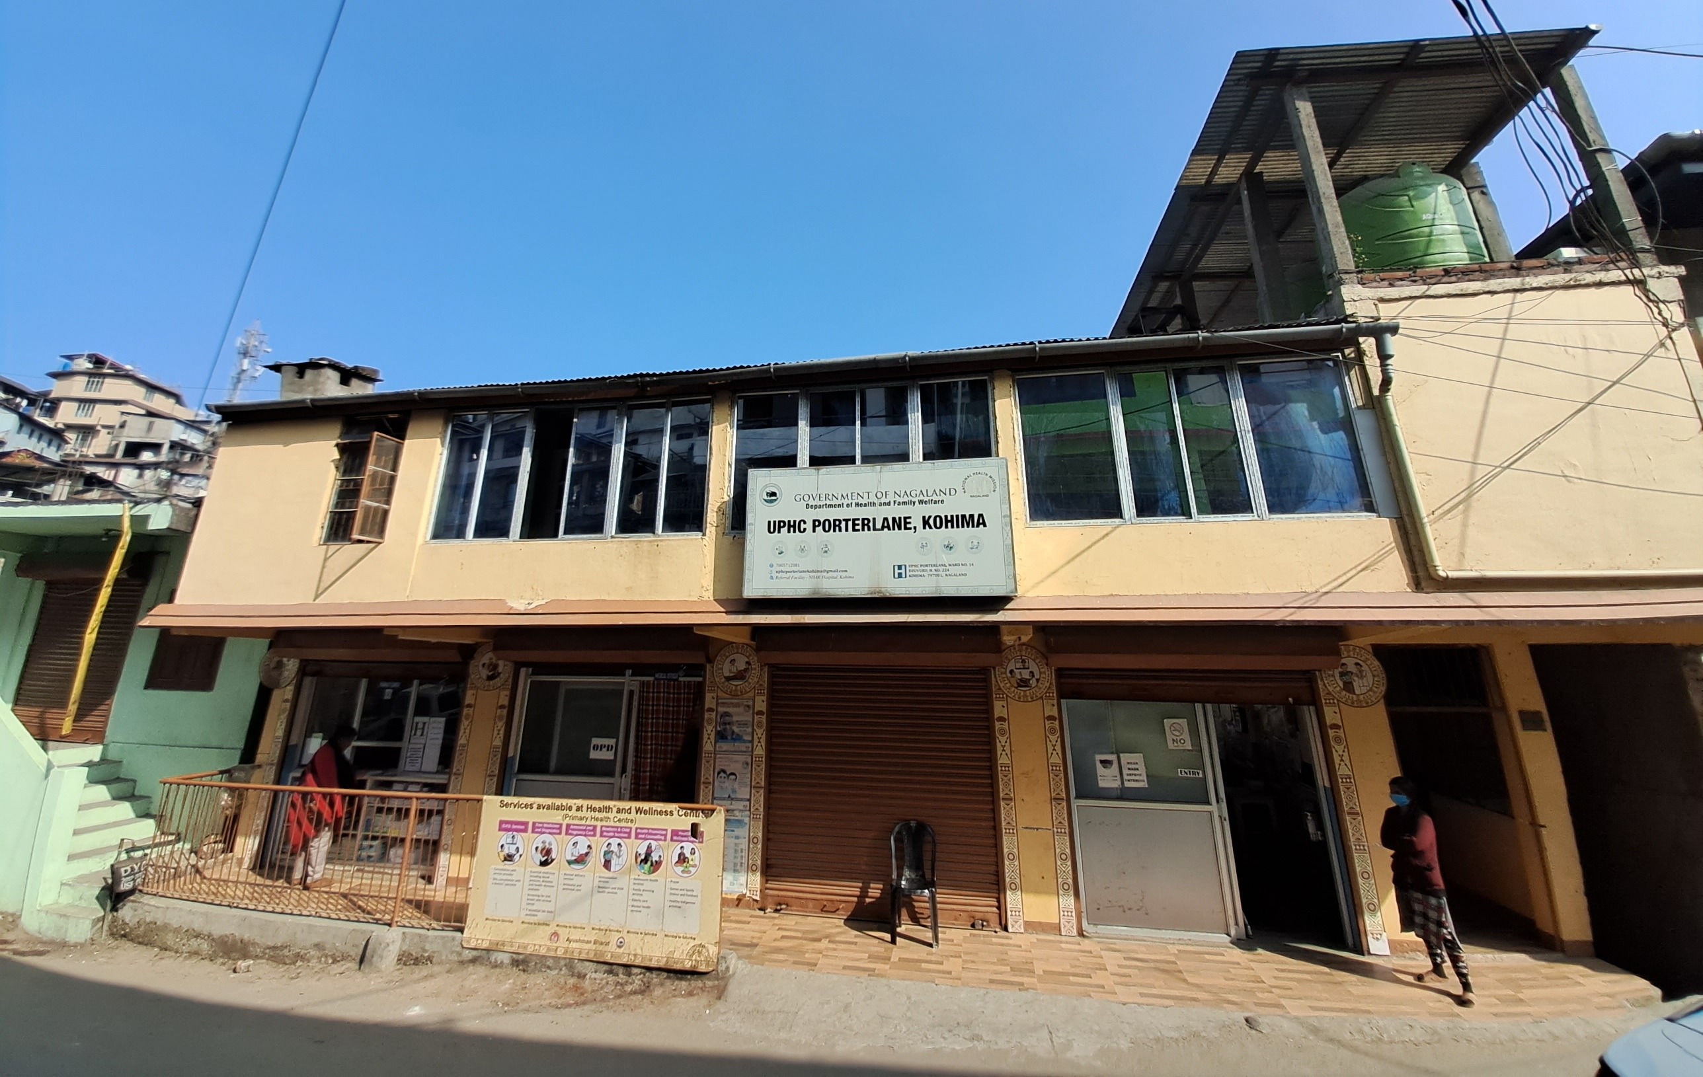

***URBAN PRIMARY HEALTH CENTRE PORTERLANE, DZUVURU, KOHIMA, NAGALAND***

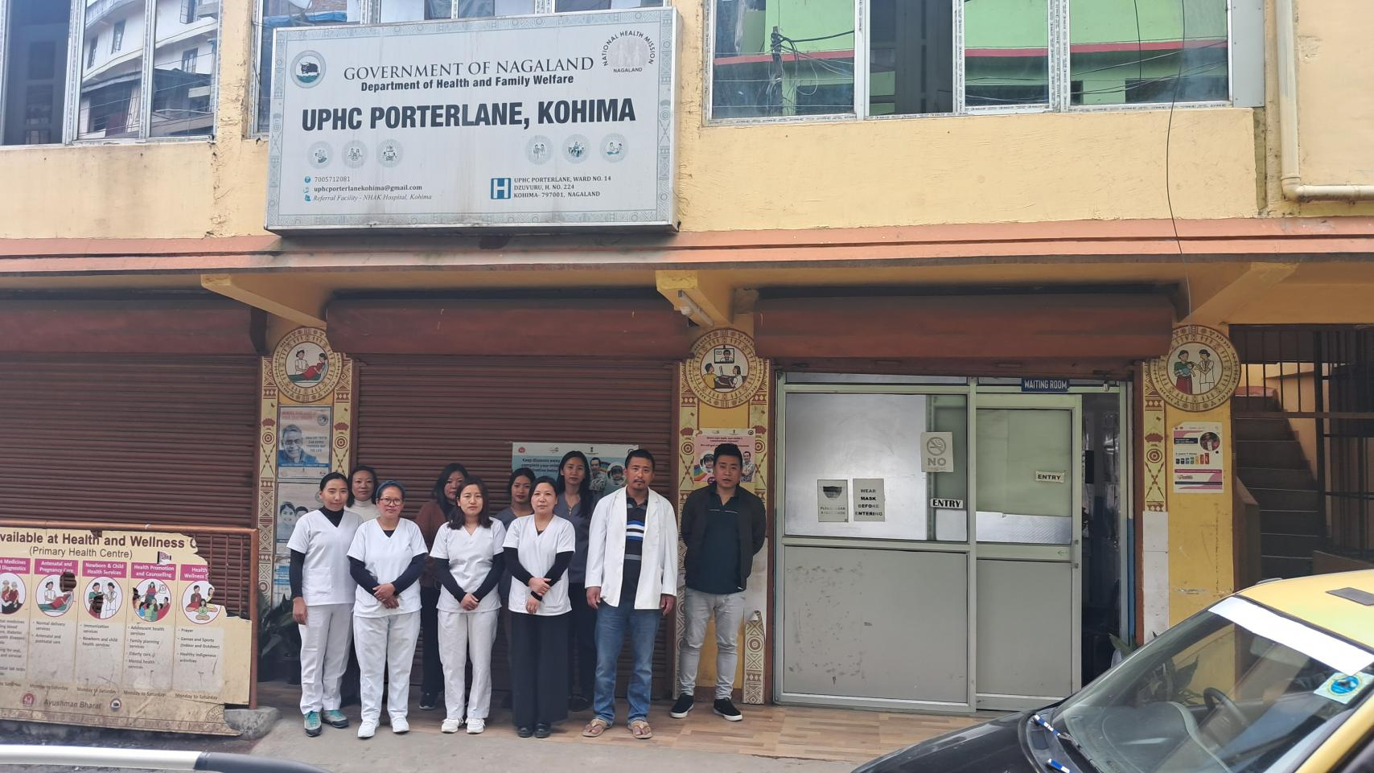

***UPHC PORTERLANE STAFF***

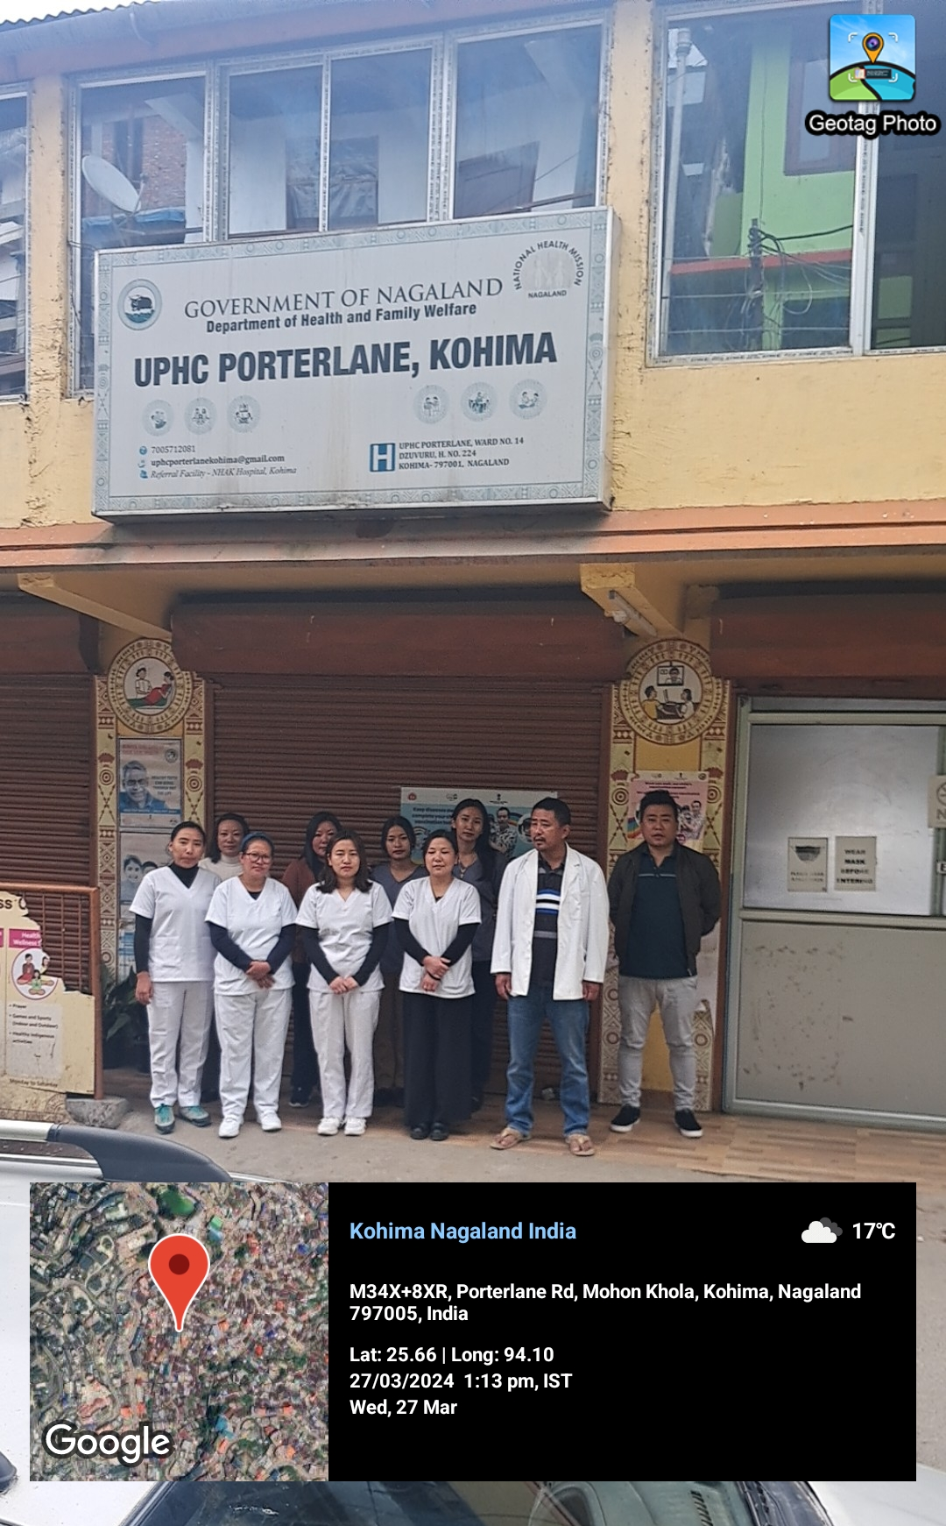

***UPHC PORTERLANE STAFF***

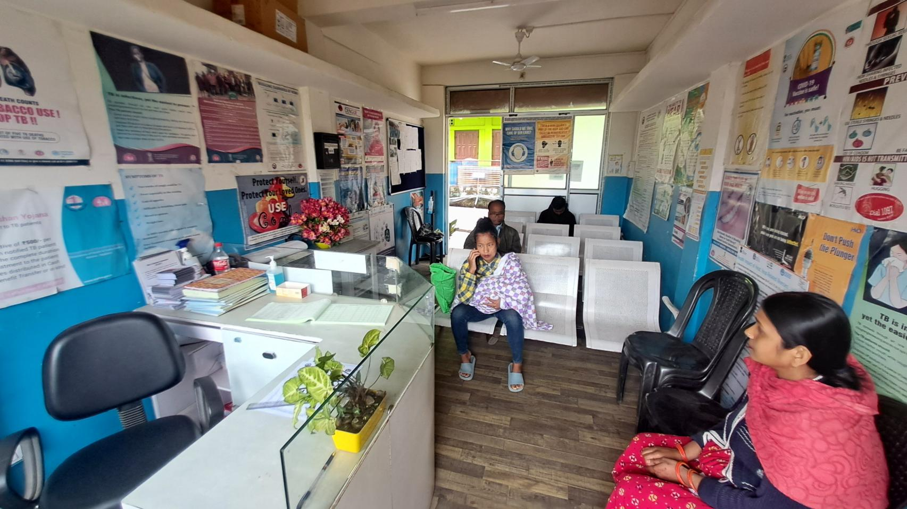

***REGISTRATION/WAITING ROOM***

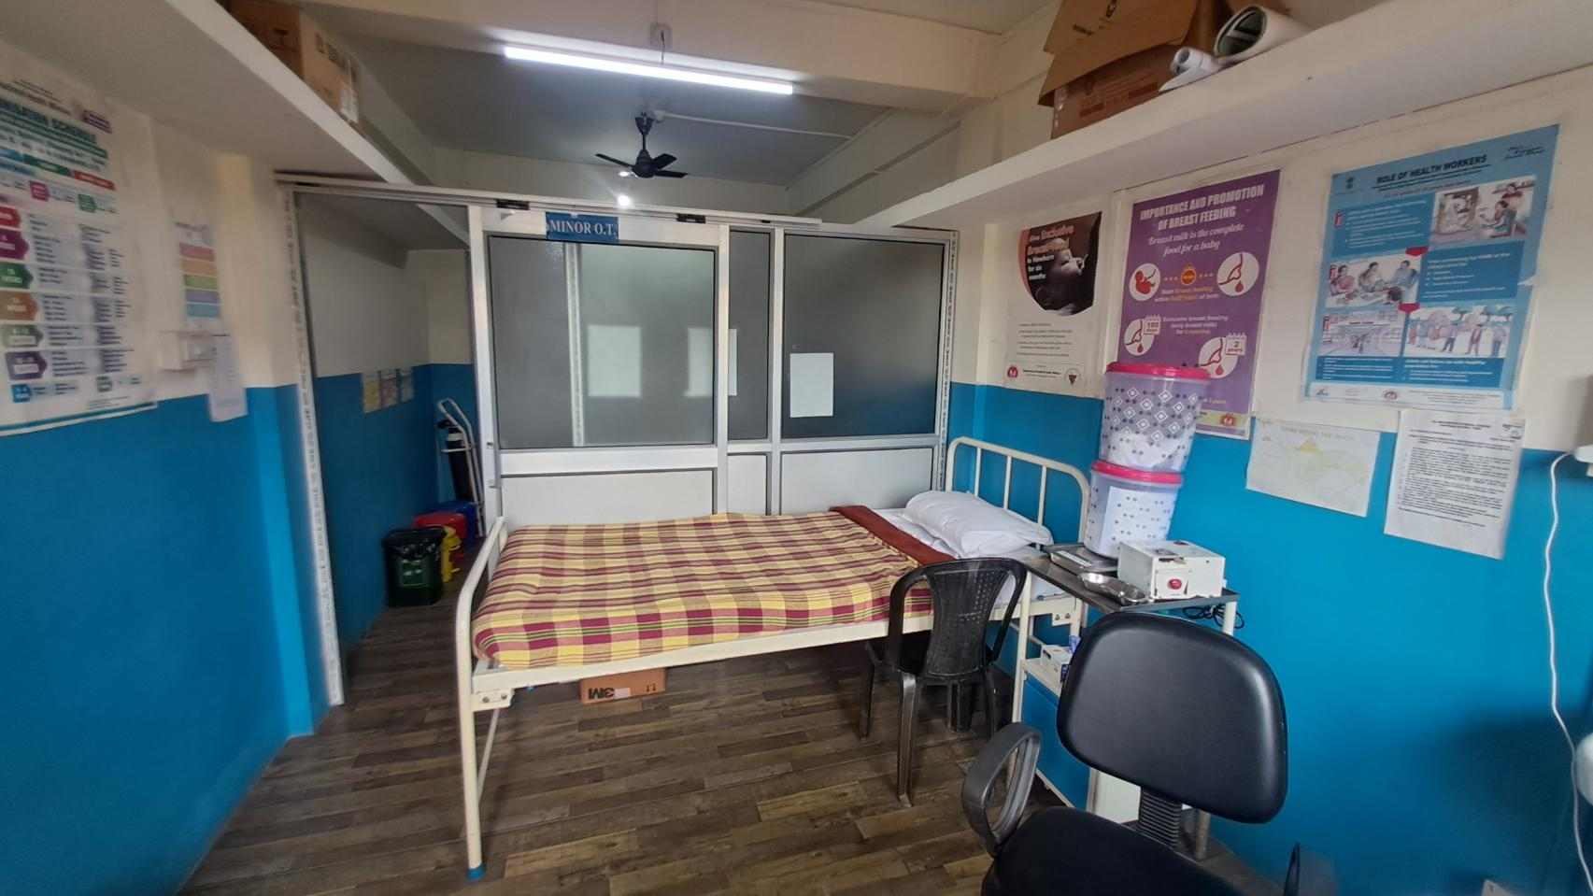

***EMERGENCY ROOM***

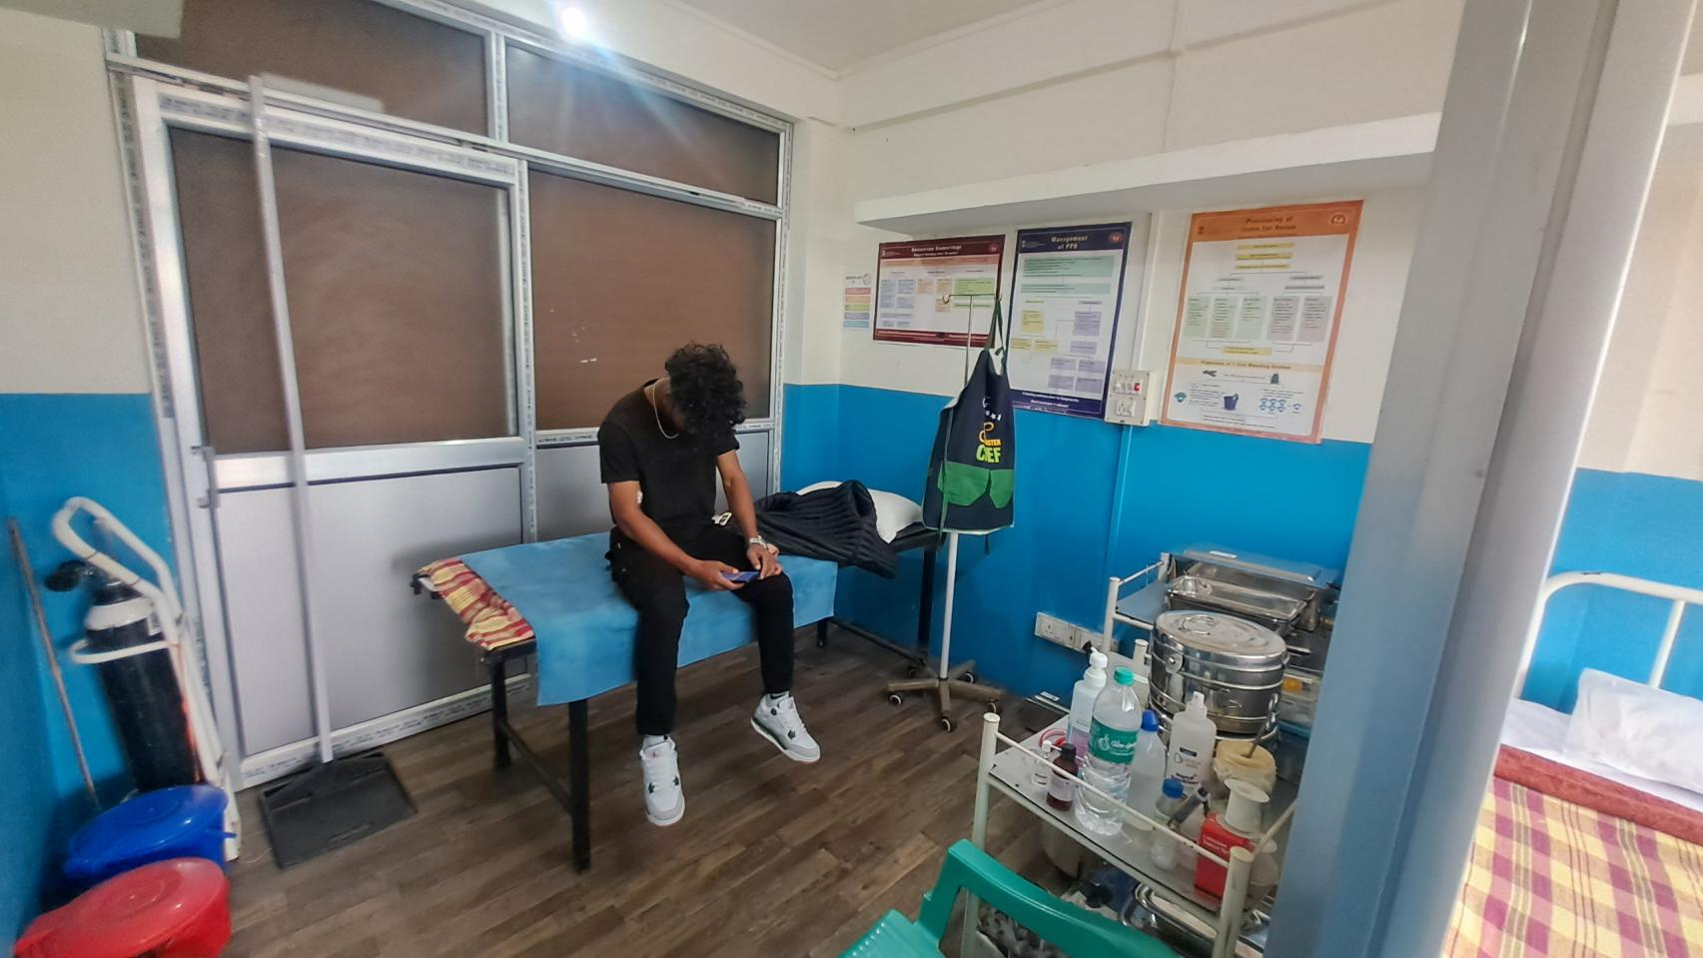

***MINOR OT***

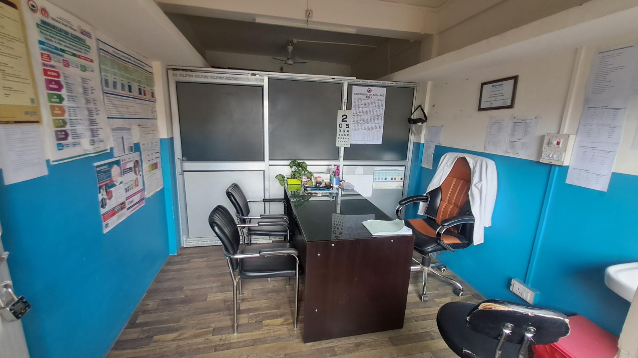

***MO ROOM 1***

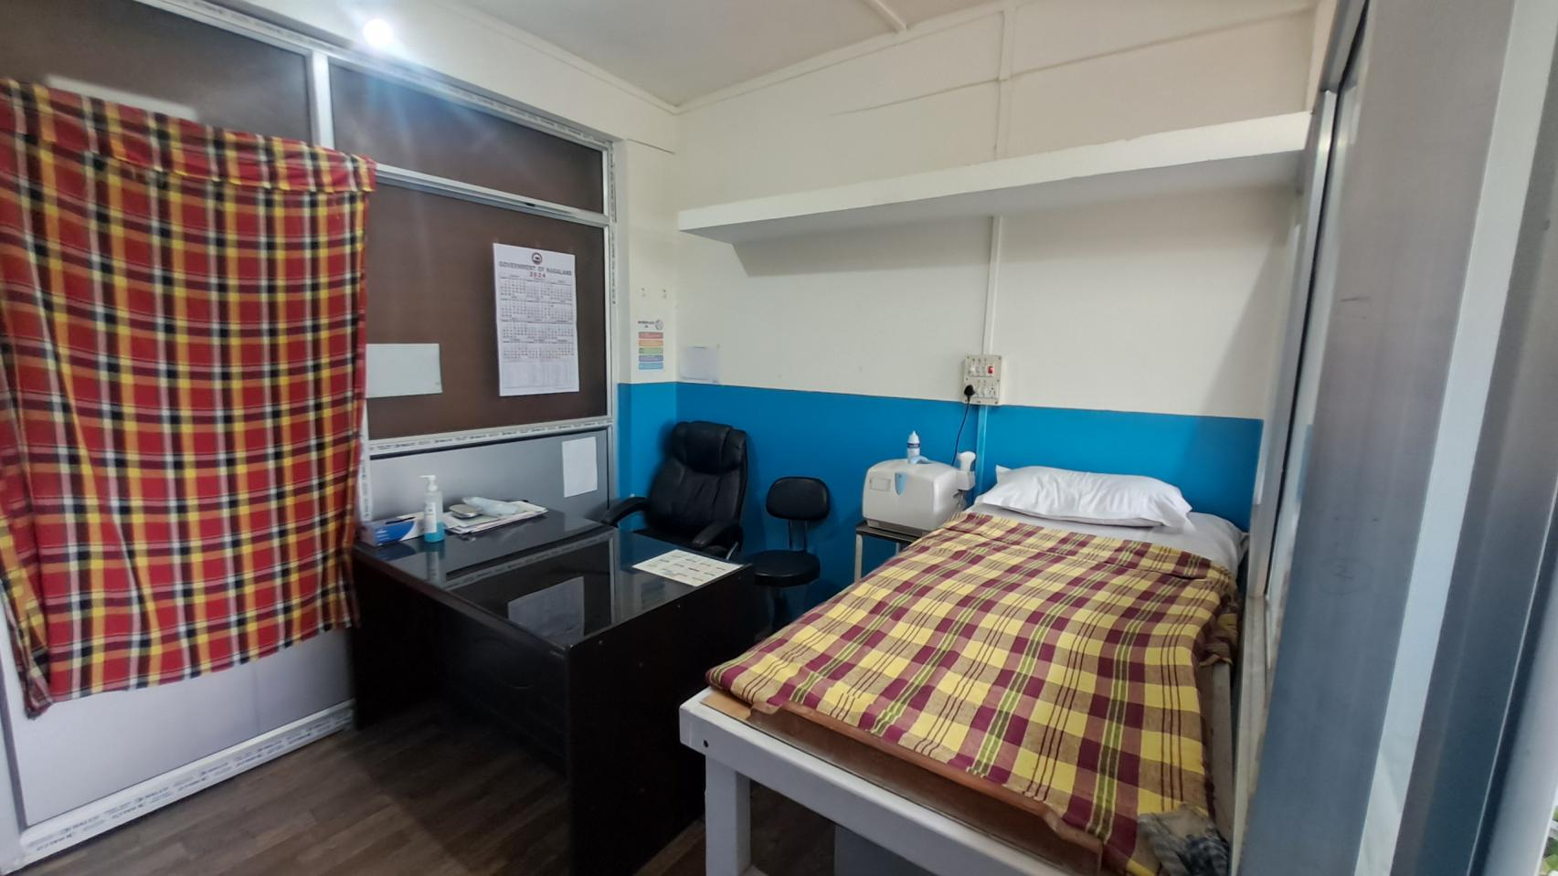

***MO ROOM 2***

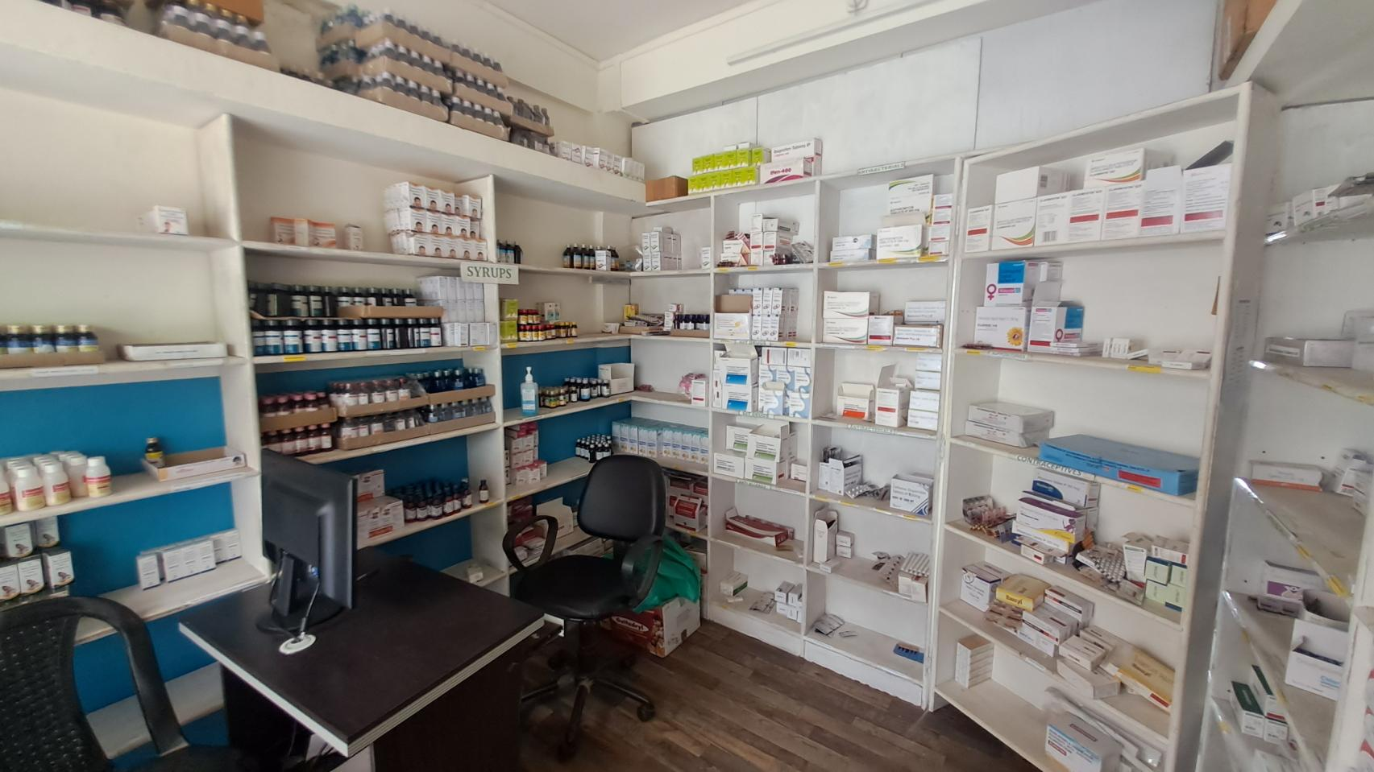

***PHARMACY***

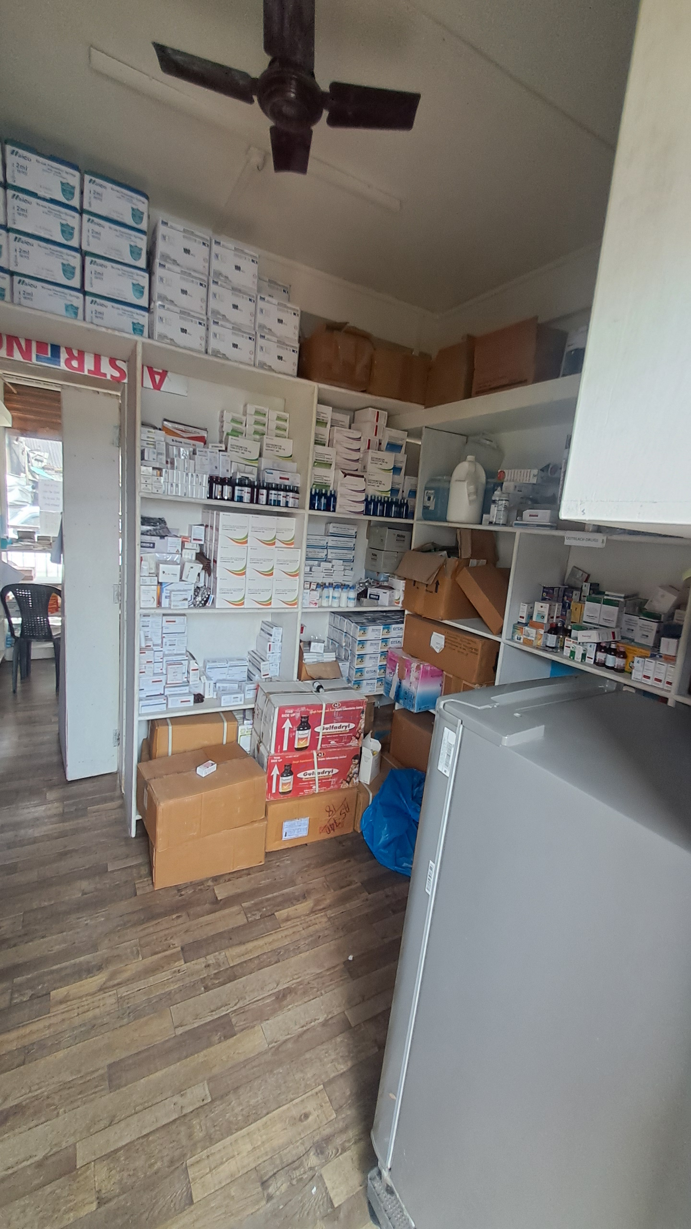

***PHARMACY***

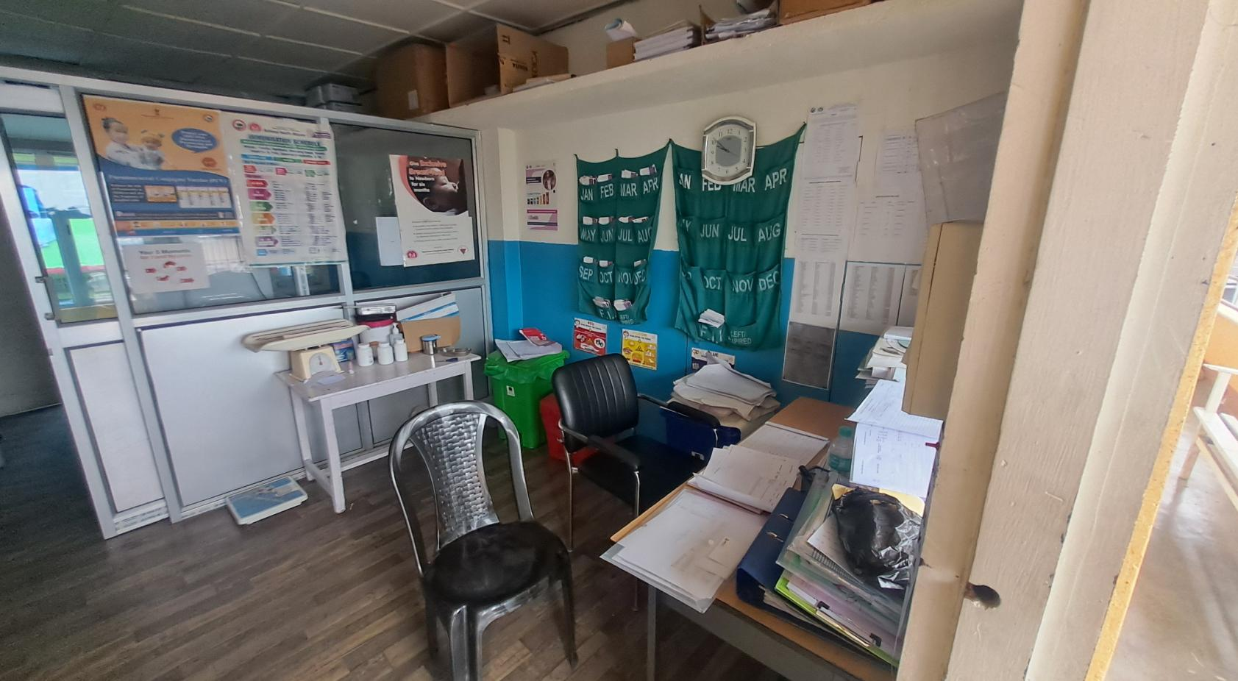

***IMMUNIZATION ROOM***

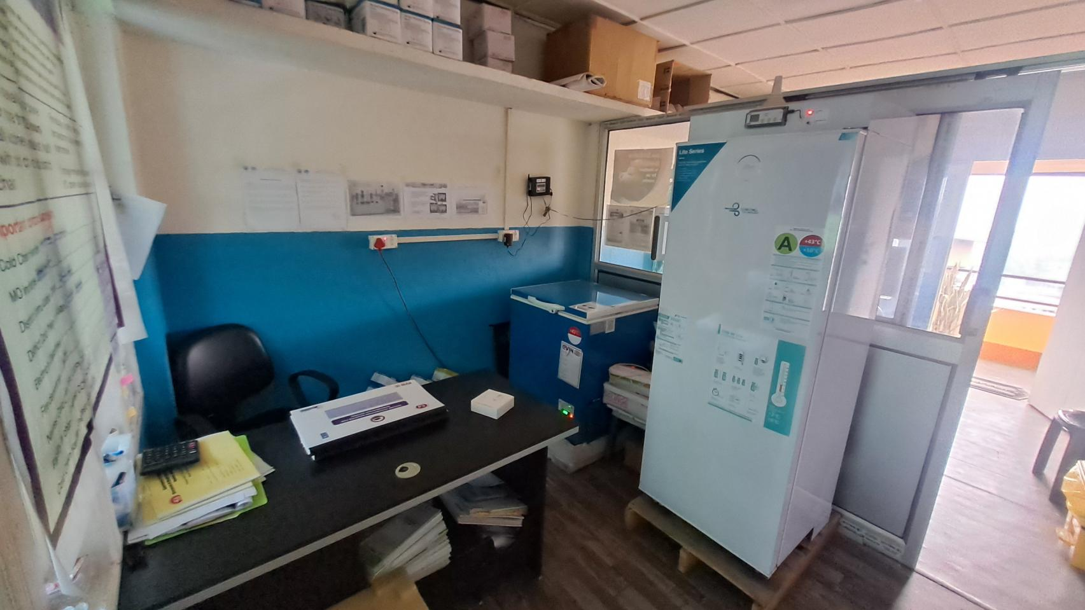

***COLD CHAIN***

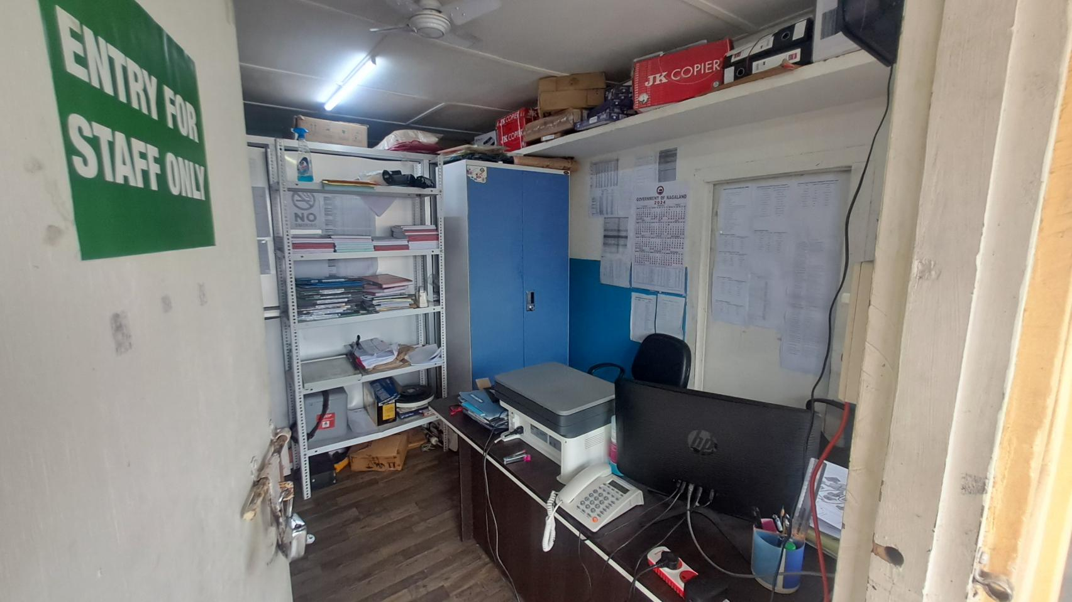

***OFFICE***

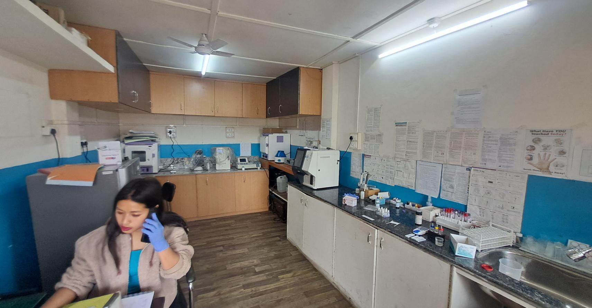

***LABORATORY***

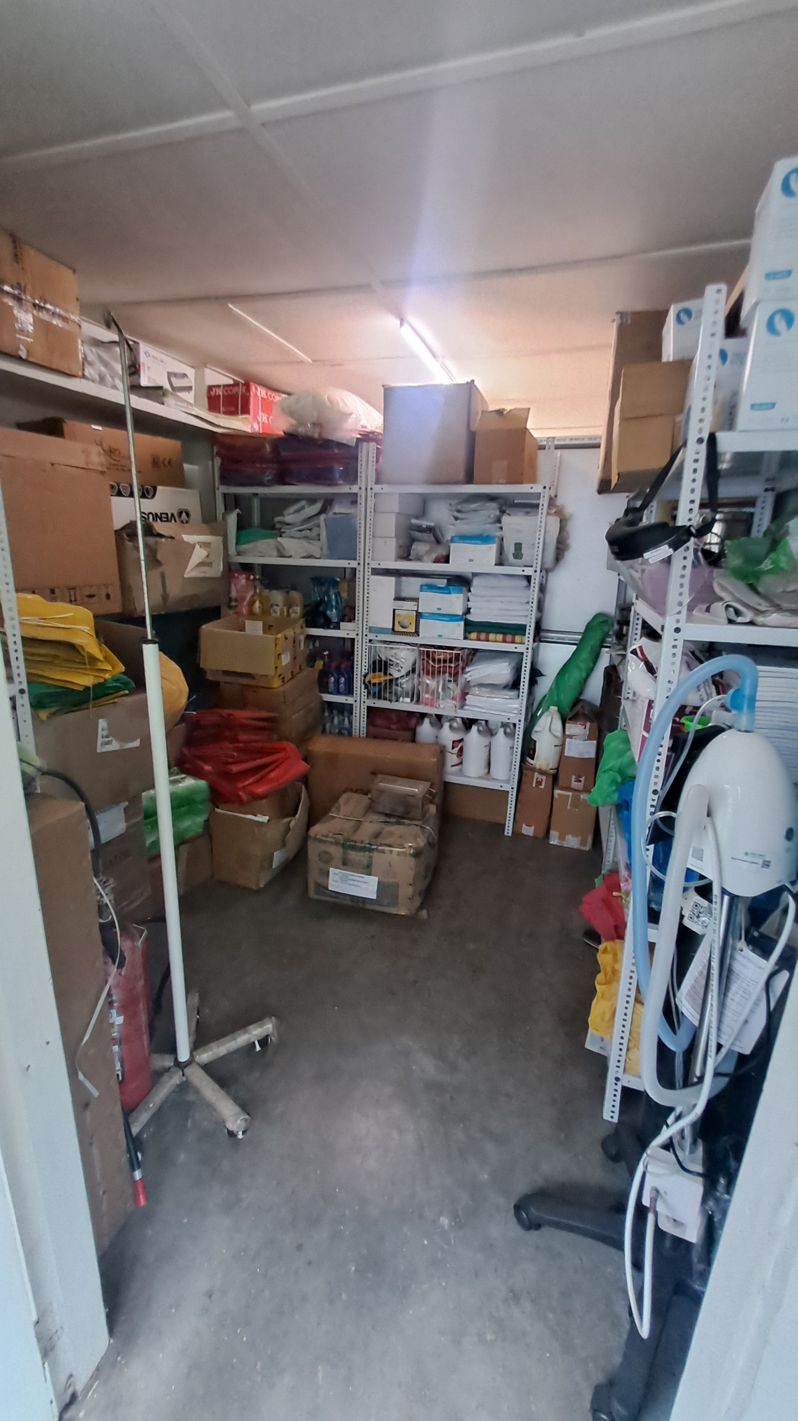

***STORE ROOM***